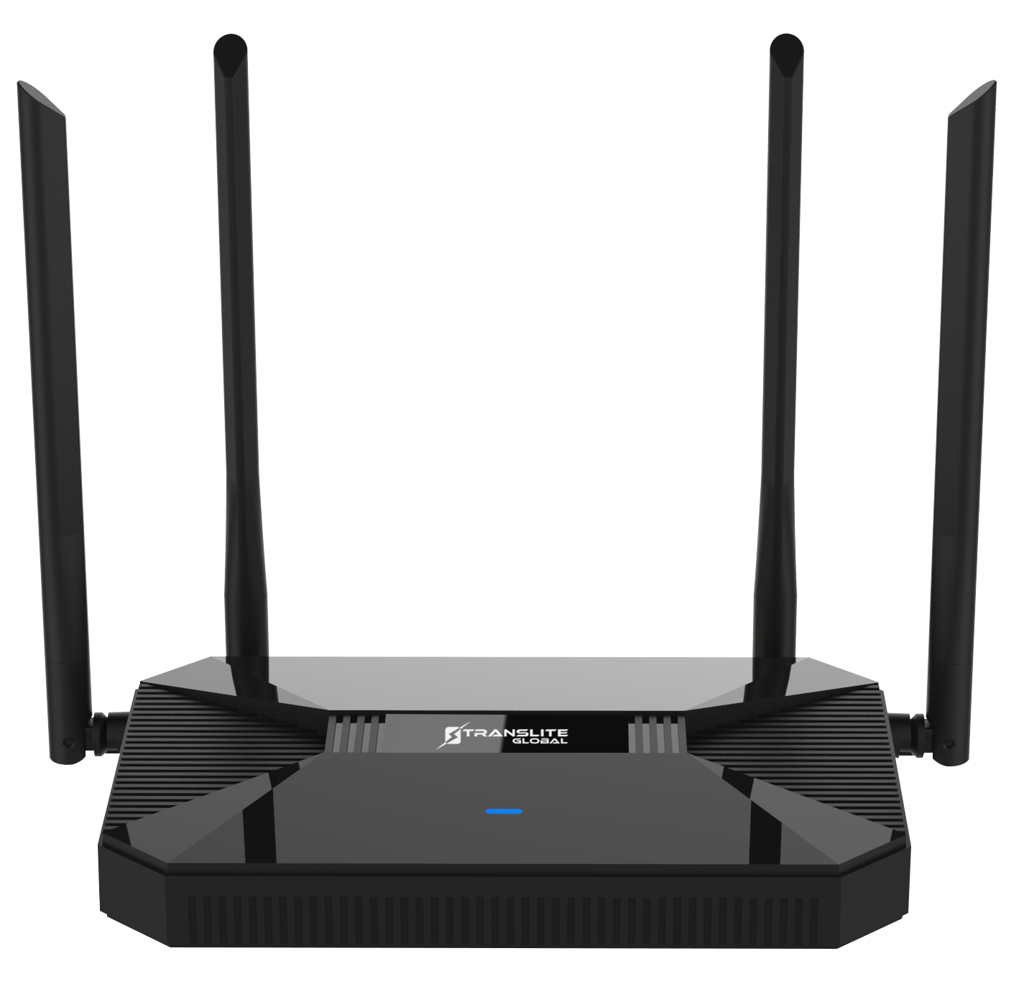
PRODUCT MODEL NUMBER: TL-HWR-13 1200Mbps Dual Band Smart Wireless Router

ABOUT THIS MANUAL
DISCLAIMER
No part of this document may be reproduced in any form without the written permission of the copyright owner.
The contents of this document are subject to revision without notice due to continued progress in methodology, design and manufacturing. TRANSLITE GLOBAL LLC shall have no liability for any error or damage of any kind resulting from the use of this document.

COPY WARNING
This document includes some confidential information. Its usage is limited to the owners of the product that it is relevant to. It cannot be copied, modified, or translated in another language without prior written authorization from TRANSLITE GLOBAL LLC

INDEX
TABLE OF CONTENTS

Chapter 1 oVERVIEW 3
1.1 INTERFACE 3
1.2 LED LIGHTS 3
1.3 CONNECT ROUTER WITH PC 4
CHAPTER 2 LOGIN TO THE WEB 5
CHAPTER 3 WEB GUI CONFIGURATION 8
3.1 USER MANAGER 9
3.2 SETUP WIZARD 10
3.3 WiFi SETTINGS 13
3.4 LAN SETTINGS 16
3.5 WAN 17
3.6 URL FILTER 19
3.7 TIME REBOOT 20
3.8 DEVICE AND ADVANCED SETTINGS 20

CHAPTER 1

OVERVIEW

  - INTERFACE

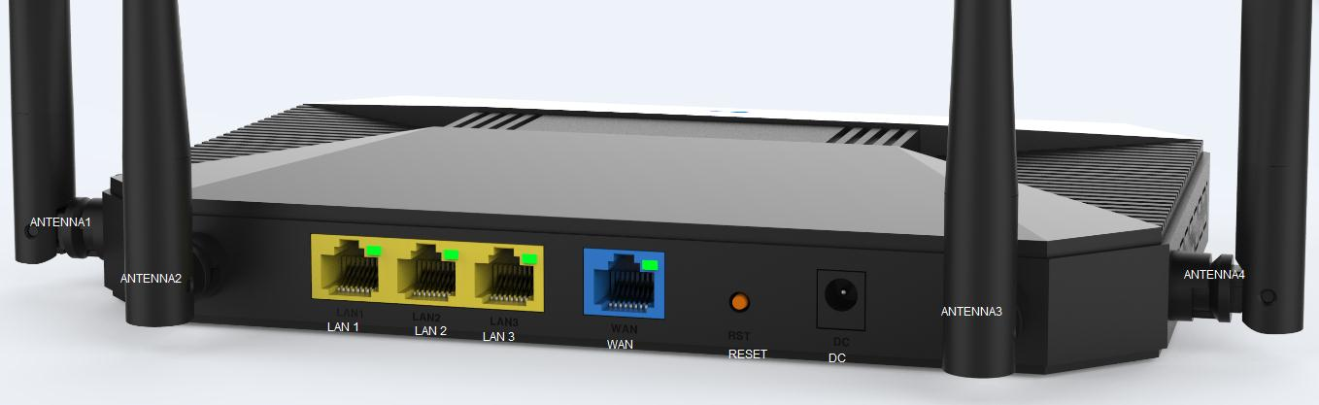
P1 Router Interface

  - LED LIGHTS

LED Indicator Instruction
LED | Status | Description
Power LED | Blue | Power On
WAN | Green | Ethernet Connected
LAN | Green | LAN Connected
Internet | Green/Blue | Internet Link Up: Green; Internet Link down: Blue

  - CONNECTING ROUTER WITH PC

User can connect the PC with wireless router by Wireless SSID and LAN cable:

The diagram of wireless connection showed as follow:
Please note: the default SSID is Wireless2.4G, SSID’s password is 66666666
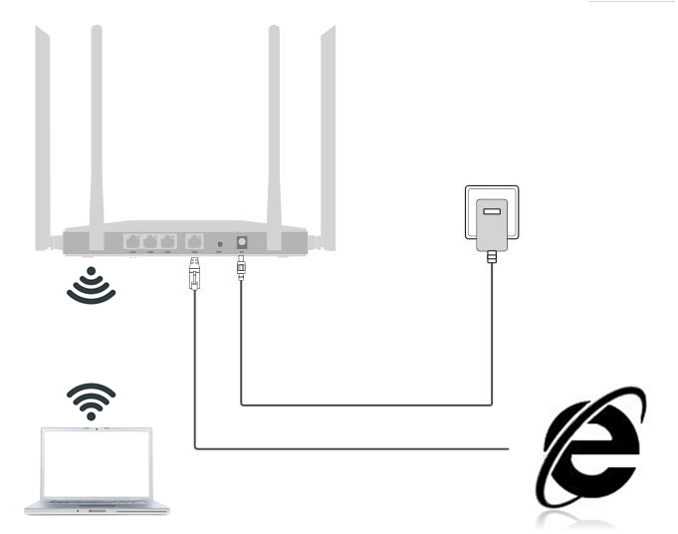
Connect router with PC in Wi-Fi

The diagram of LAN cable connection showed as follow:

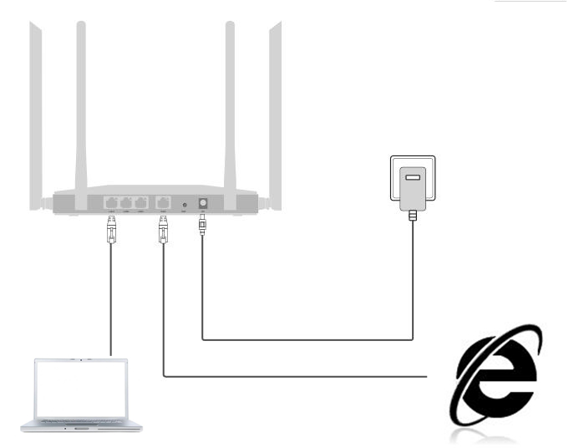
Connect router with PC in LAN Port

CHAPTER 2

LOGIN TO THE WEB

2.1 Power on this wireless router, connect PC with wireless router as chapter 1 connection.

2.2 Click Internet Explorer and input 192.168.188.253 on the address bar, then press Enter, following page will pop up.

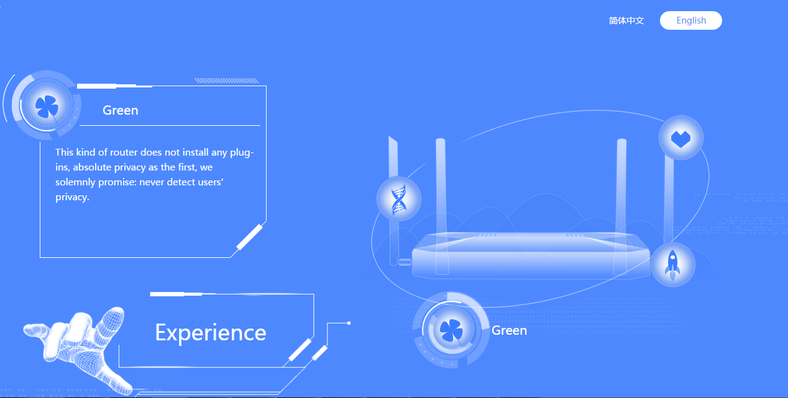

Click Experience to go on, the router will pop up a window ask for select router mode – the options are Gateway mode and Sub-node Mode(Mesh Mode).

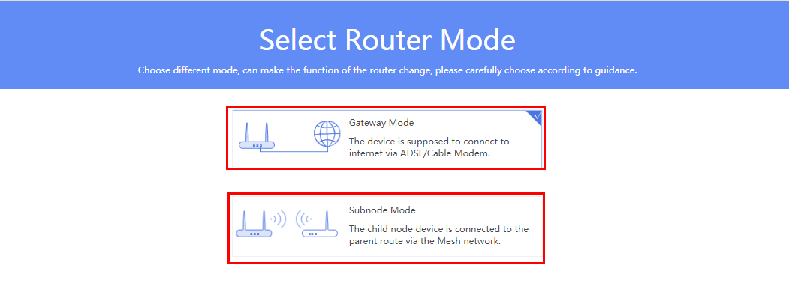

When you choose Gateway mode, it will scan the Internet connected method at first
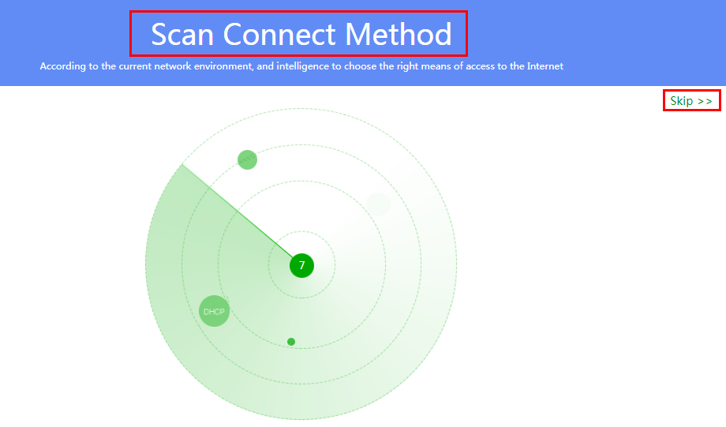

If the scan fails, the user will be prompted to wither detect the connection or skip the step.
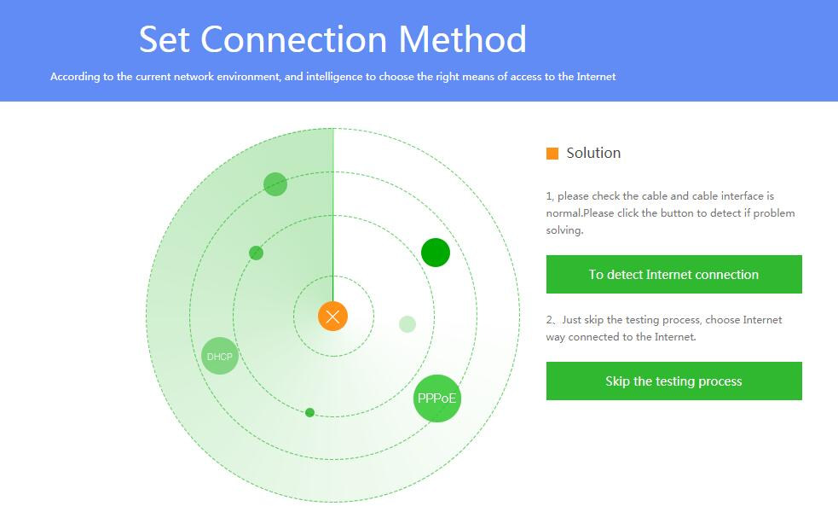

If the user skips the testing process, the following is the next step where the connection method will have to be chosen:

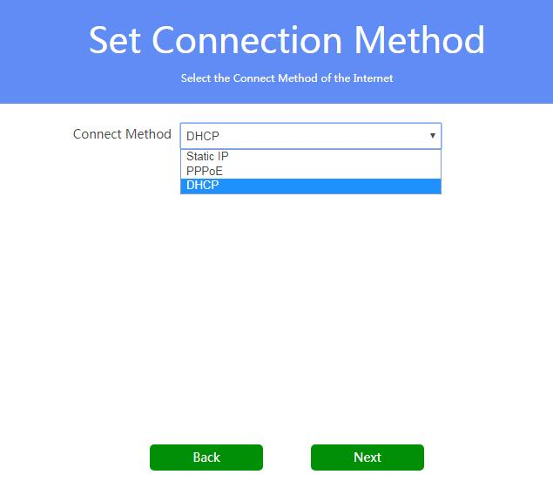

Click Next to continue to the Wi-Fi setting:
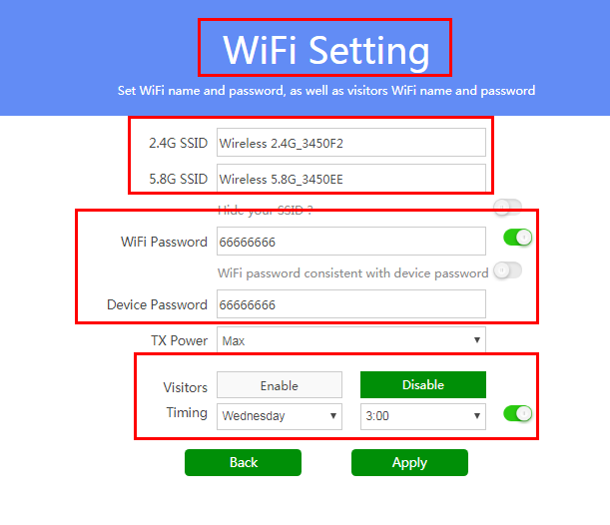
Apply to finish, a login page will pop up, input Device Password, then click Login to Enter.
CHAPTER 3

WEB GUI CONFIGURATION

Once logged in, the following home page will be displayed:
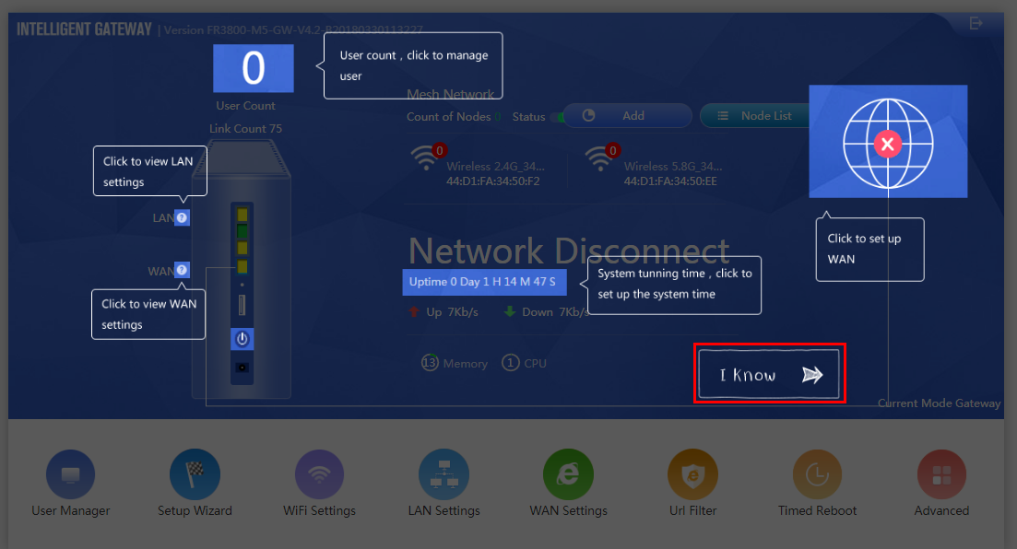
Home page

Click ‘I know’ to continue:
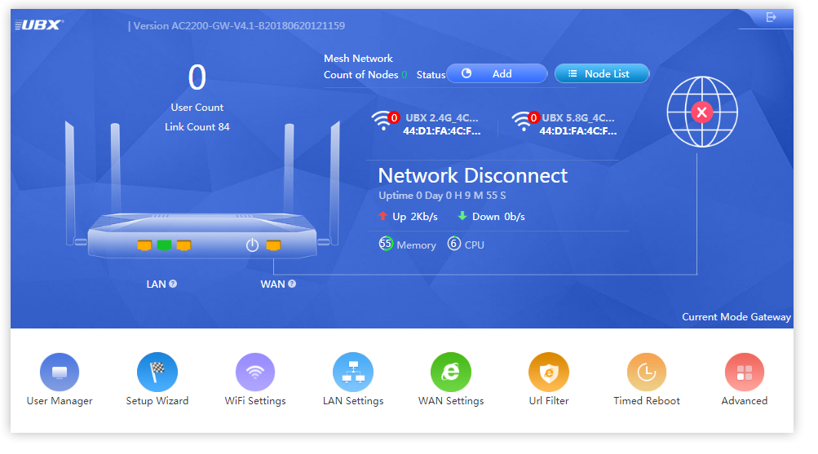
The below topics show how to configure User Manager, Setup Wizard, Wi-Fi Setting, LAN Setting, WAN Setting, URL Filter, Timed Reboot and advanced functions.
3.1. User Manager
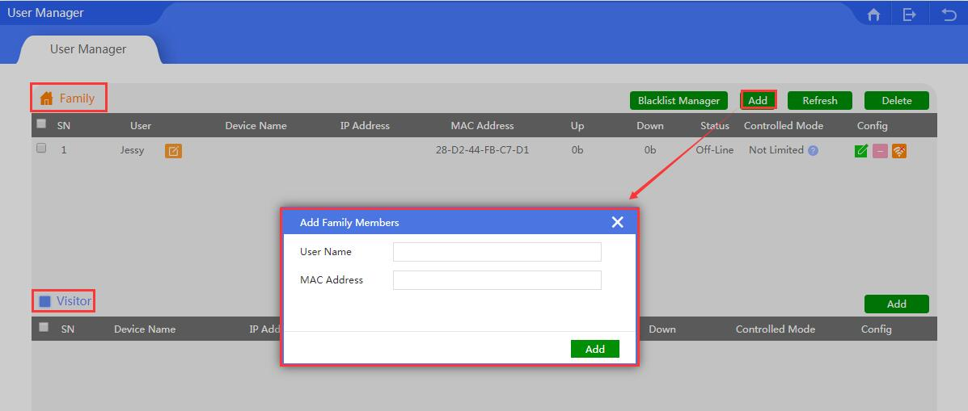
In user manager section, one can manage the network behavior of family members and visitors.
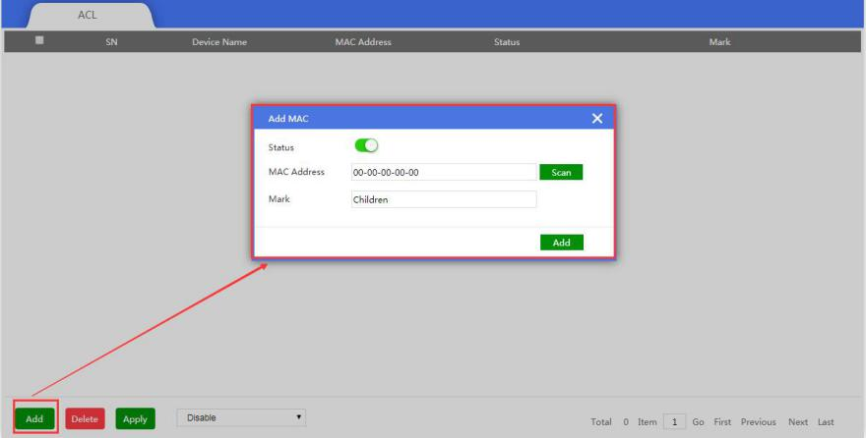

Config: To control the Ethernet behavior or Ethernet time, configuration showed as follow
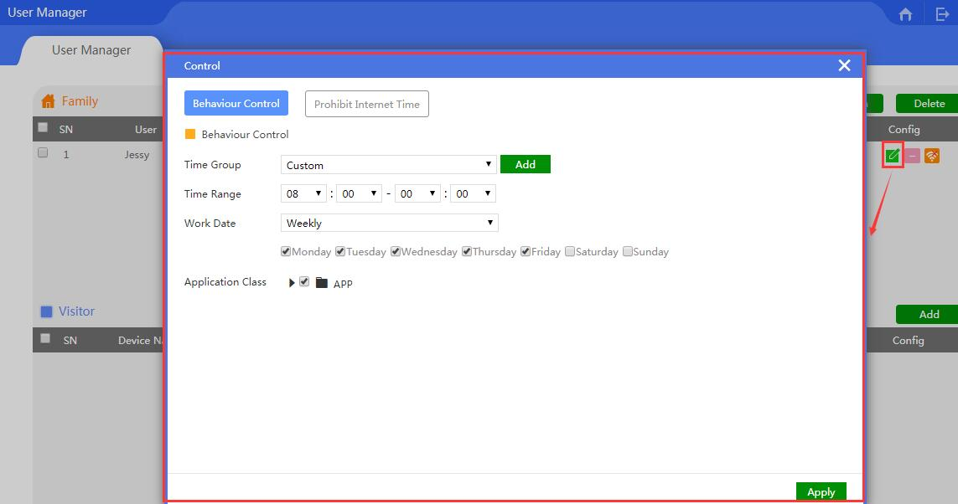

3.2. Setup Wizard
There are three operation modes in this router: Gateway, Wi-Fi Repeater and AP Mode.
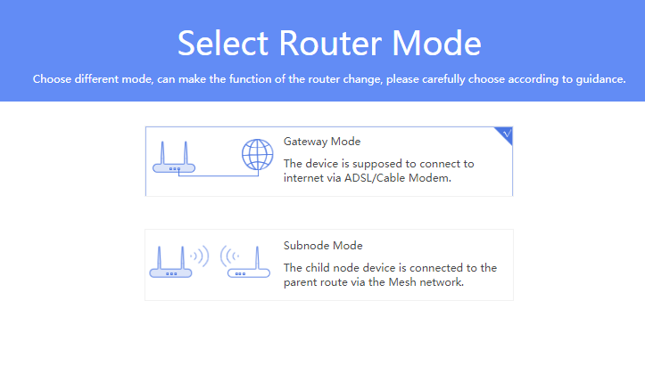
3.2.1 Gateway Mode
The device is supposed to be connected to internet via ADSL/Cable Modem; for this part, please check more information from Chapter 2.

3.2.2 Sub node Mode
In sub node mode, the user can extend the existing wireless signal to boost Wi-Fi range through wireless connection, even if one of sub node breaks down, the other sub nodes will work fine still.
Before selecting this mode, kindly ensure that you have two units of mesh wireless routers on hand.
In addition, you will have to set one of the mesh wireless routers in Gateway mode.

Please note: different LED colors indicate different status, kindly refer to following table.
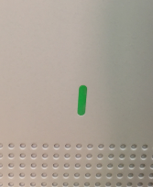

LED Light | Power On | Internet Work | Internet not work | Mesh Connecting | Mesh Connected
Gateway Mode | Blue Color, Flash | Green Color, Flash |  | Green color and blue color twinkle | Blue Color, Flash
Subnode Mode | Blue Color, Flash | Green Color, Flash | Blue Color, Flash | Green color and blue color twinkle | Blue Color, Flash

- Set one of the mesh wireless routers in Sub node Mode.
- After selecting Sub node mode, the device will request to reboot at first, confirm the reboot and wait for the device to restart.
- After reboot, input the password to login to the wireless router again, which will show the working status of sub node mode as the below image:
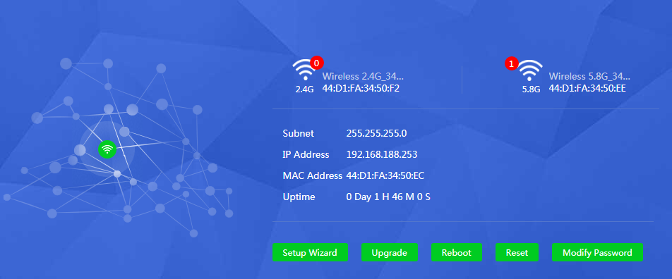
As the above image displays, one can setup the operation mode, upgrade device firmware, reboot this device and modify the login password.

Please press the reset button for one second of mesh wireless router in gateway mode, it will search and connect with the mesh wireless router in sub node mode. When connecting, the LED light will blink in green and blue color. When connected, LED light flash in blue color.
Once the two mesh wireless routers are connected, then login using 192.168.188.253 as IP address, it will provide access into the mesh wireless router in Gateway mode.
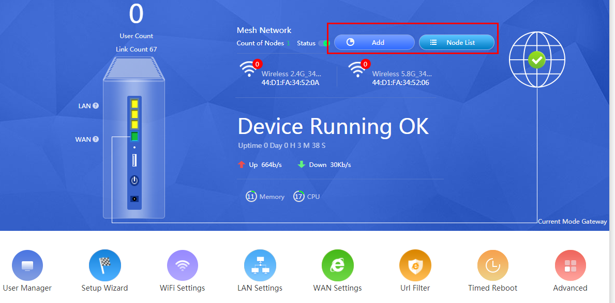
If you wish to add more sub nodes, you can configure it from the home page as shown above. The device management will scan and add more sub nodes, if needed.
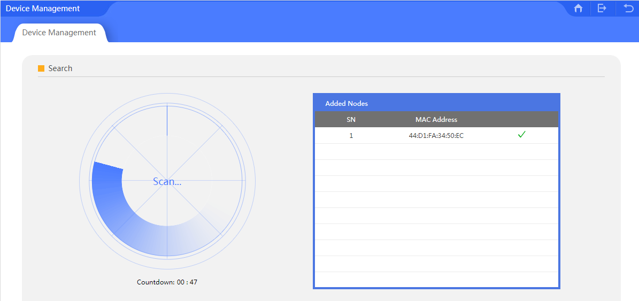

3.3 Wi-Fi Settings
This includes basic wireless setting, advanced wireless settings, TX Power.

3.3.1 Basic
The basic wireless settings, includes master and visitors network.
User can configure the data based on their requirements as shown in the following picture:
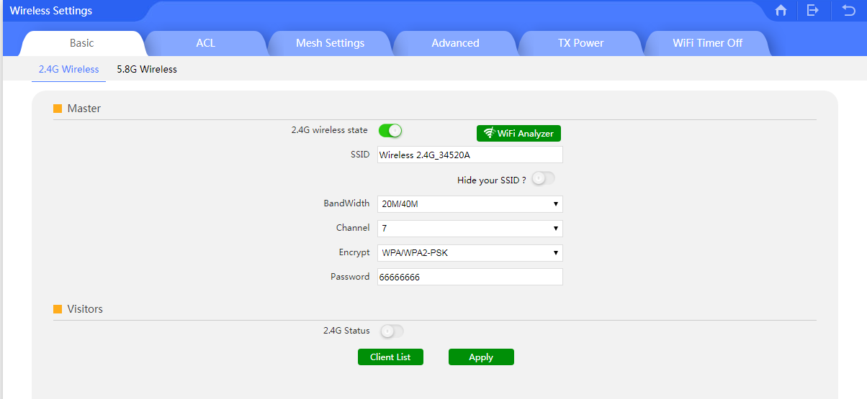

There is a Wi-Fi analyzer tool in this router, which can help user to choose the best channel, and avoid the Wi-Fi interference.
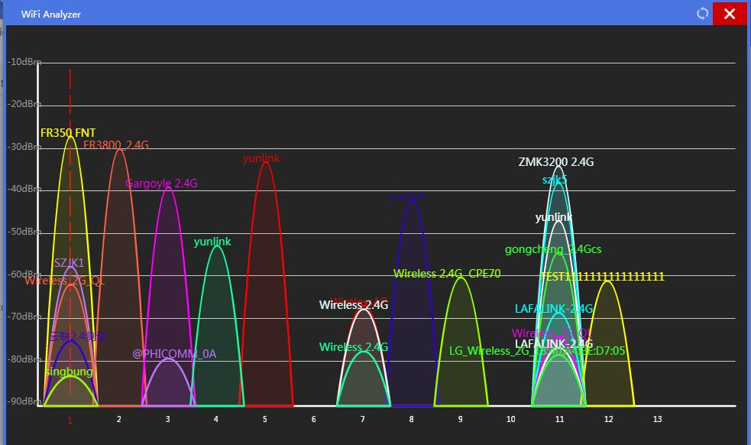

3.3.2 ACL
This is a MAC filter. To control the user access, one can add/delete the user’s MAC address based on requirement:
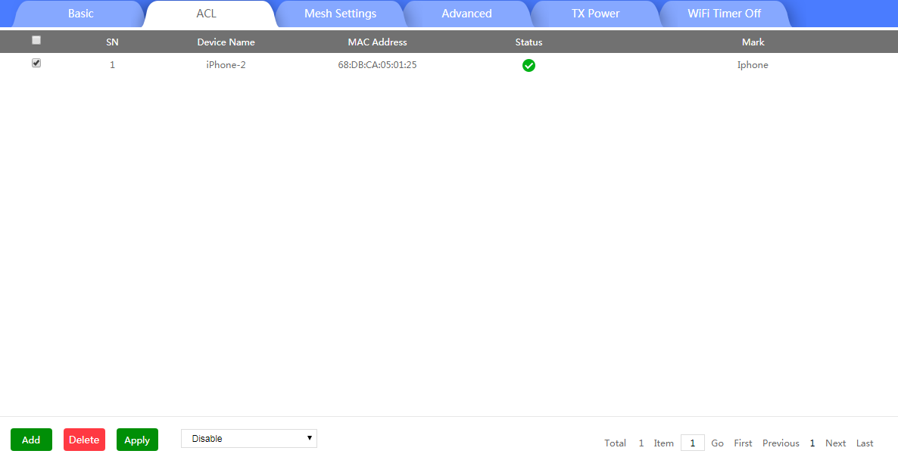

3.3.3 Mesh Settings
The user can enable or disable the mesh function.
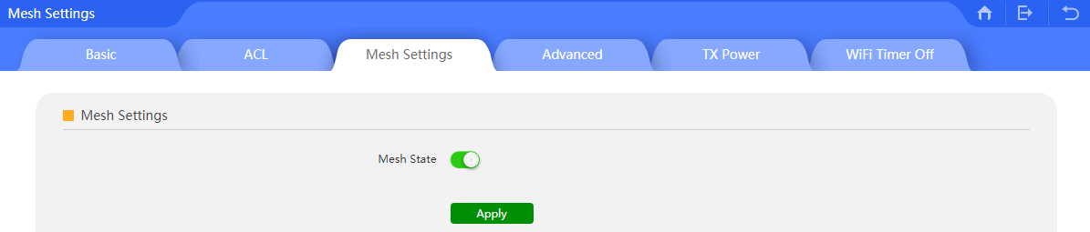

3.3.4 Advanced
Under Advanced, the user can set the right country code, client count, coverage threshold based on requirement:
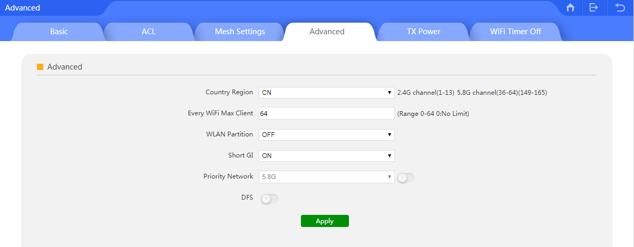

3.3.5 TX Power
In this part, user can adjust the router’s TX power to control the wireless signal range.
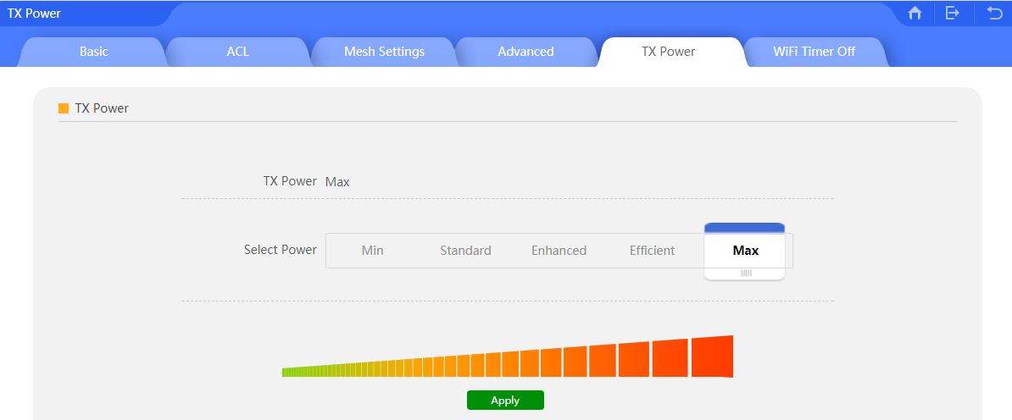

3.3.6 Wi-Fi Timer Off
In this part, user can enable/disable wireless signal in central time to save energy.
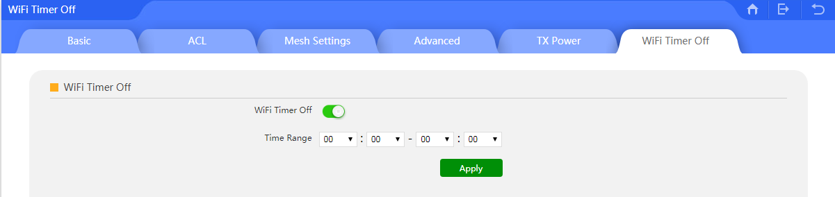

3.4 LAN Settings
This includes LAN settings and Static DHCP settings.

3.4.1 LAN Setting:

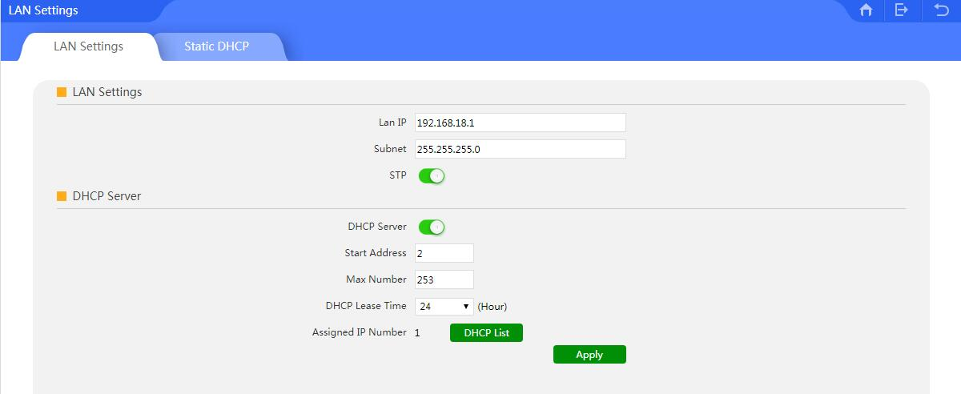

IP address: The controller’s IP address
Subnet Mask: To set the subnet of LAN
STP: Spanning Tree: Enable this feature to show the assigned IP list in DHCP list
DHCP Server: Enable this feature to assign IP address automatically.
Start Address: The DHCP block start IP address
Max Number: The maximum number of DHCP addresses
DHCP Lease Time: The IP address lease time by DHCP server
Assigned IP Number: The number of IP address that are DHCP assigned.

3.4.2 Static DHCP
Static DHCP:
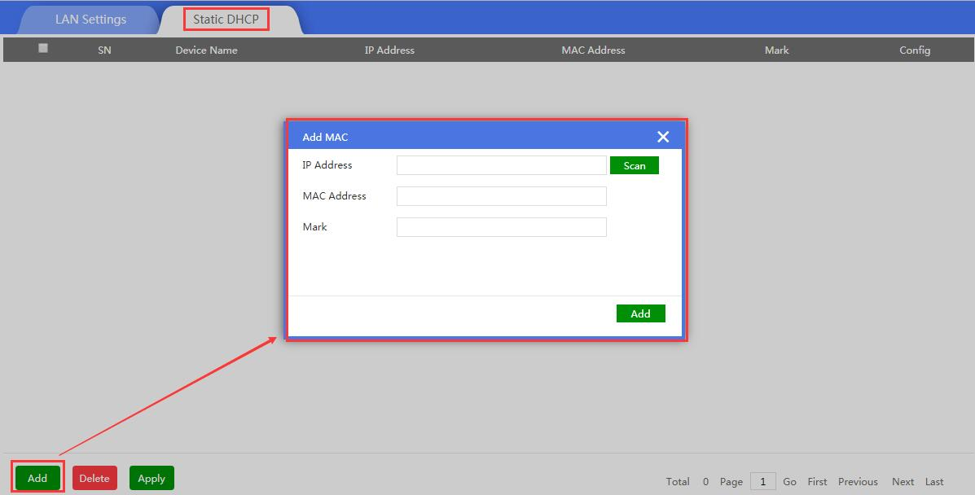

3.5. WAN
3.5.1 WAN Setting:
The WAN Setting includes DHCP, Static IP, PPPoE, as showed in the following picture:
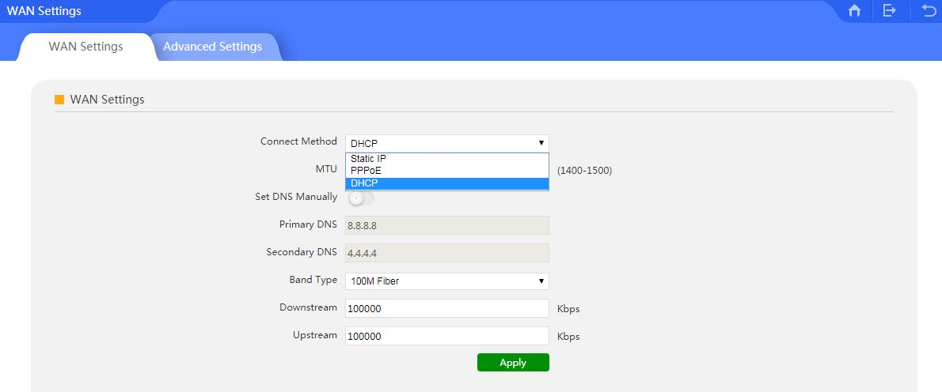

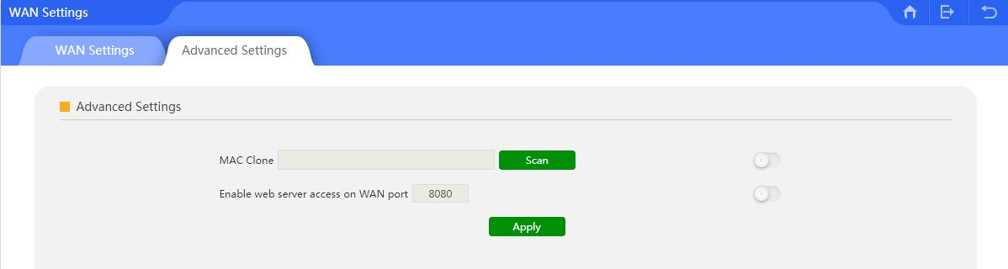

3.5.2 Advanced Setting:
The Advanced Setting mainly displays MAC Clone and Remote Management features.

MAC Clone: When enabled, it can scan the connected devices’ MAC address, choose the MAC address needed to be cloned, then apply; Or the user can input the indicated MAC address to be cloned.

Port Remote Management: When enabled, the remote management port manager can access into the WEB interface.

3.6. URL Filter
When enabled, the URL filter will prohibit the users to visit specified URLs at a certain specified time range. After selecting the URL filter, please setup the URL rule, add the time group, configure the limited time range and input URL to finish.
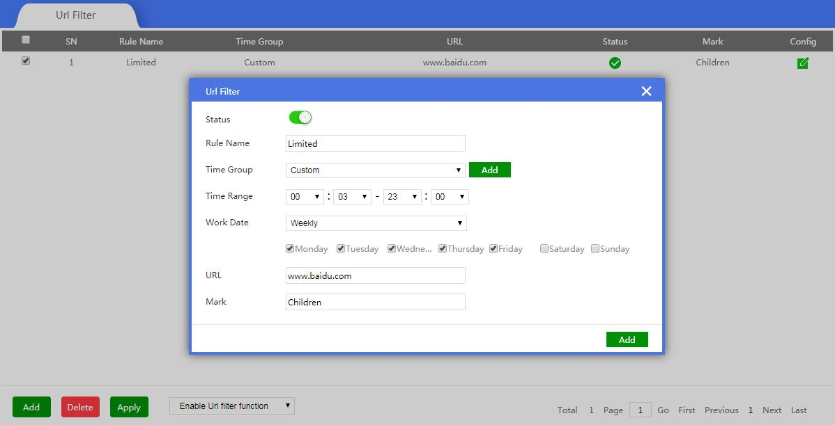

3.7 Timed Reboot
This function enables the user to setup auto reboot at certain specified time

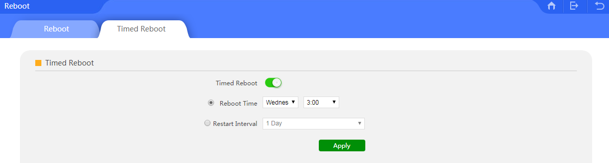

3.8 Advanced Settings
Advanced Settings includes Device settings, Common settings, Network settings and Security Settings.

3.8.1 Device:
Device settings includes router configuration, Reboot, Modify Password, Upgrade, Time, Log and USB storage.

3.8.1.1 Configure
This includes the broadband router backup, restore, and reset default.
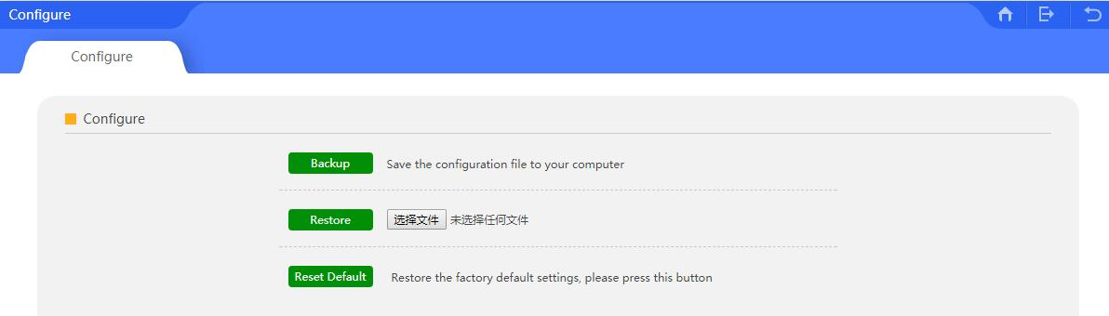
Backup
By saving the WLAN controller configuration file in the computer, the user can restore to the same configuration by using the saved file.
Restore
By using the saved configuration file, the user ca recover previous configurations.
Restore default
This will enable the user to restore to factory default settings.

3.8.1.2 Reboot
This enables to reboot the broadband router immediately or reboot the broadband router at a certain specific time.
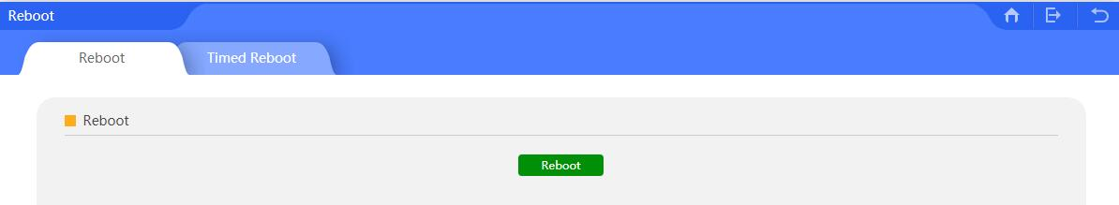

3.8.1.3 Modify Password
Modify the login password of the broadband router
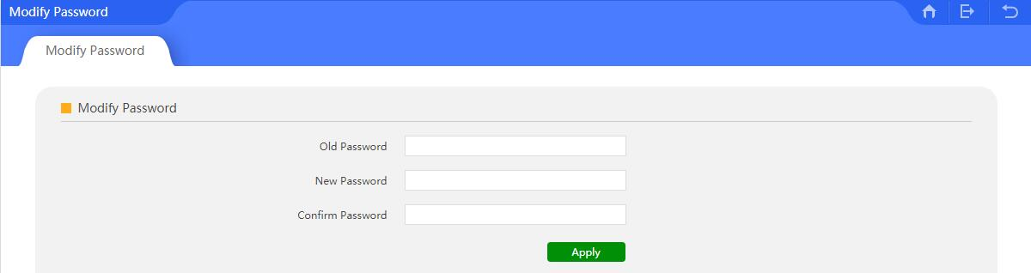

3.8.1.4 Firmware Upgrade
This feature allows upgrading firmware of the device.
Note: Upgrading software may cause local network outage. While upgrading the firmware, do not power off the device, doing so may damage the broadband router!

3.8.1.5 Device Time
Displays the broadband router’s time.
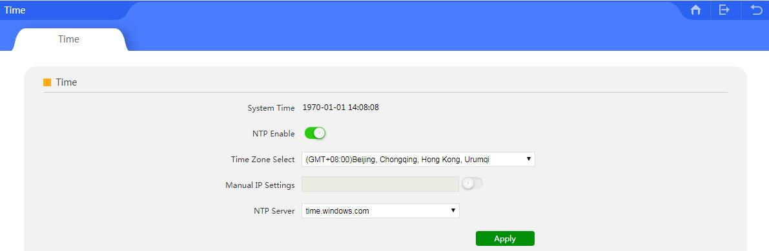

3.8.1.6. Device Log
Device Log helps to trace the router’s working status. Can be copied for further technical support.
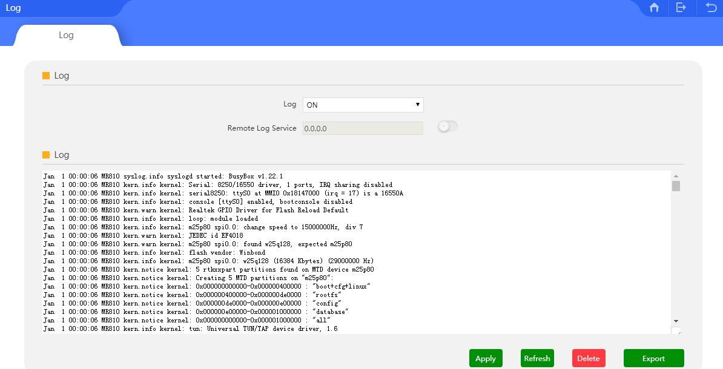

3.8.1.7. USB Storage
There is a USB port on the product as it supports the USB storage function
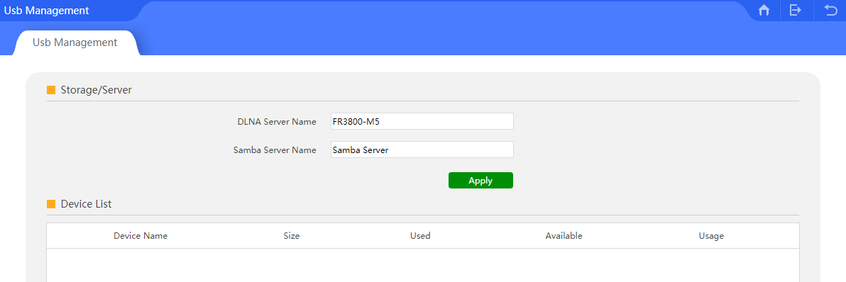
3.8.2 Common:
This includes Setup Wizard, WiFi Analyzer, User Manager, Flow Control, Behaviour, IP/Time Group, Cloud Server Settings.

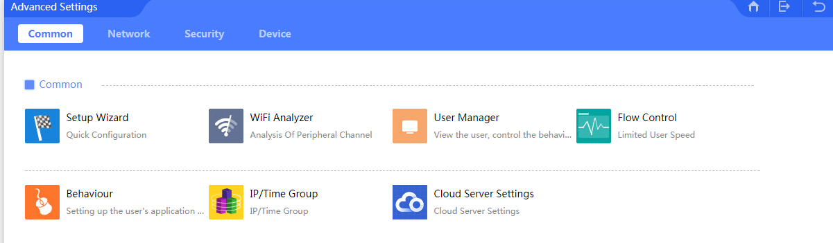
3.8.2.1 Setup Wizard
Please refer to Chapter 3.2.

3.8.2.3 Wi-Fi Analyzer
Please refer to Chapter 3.3.1

3.8.2.4 User Manager
Please refer to Chapter 3.1

3.8.2.5 IP/Time Group
IP Group: The user can add the IP groups, if required.
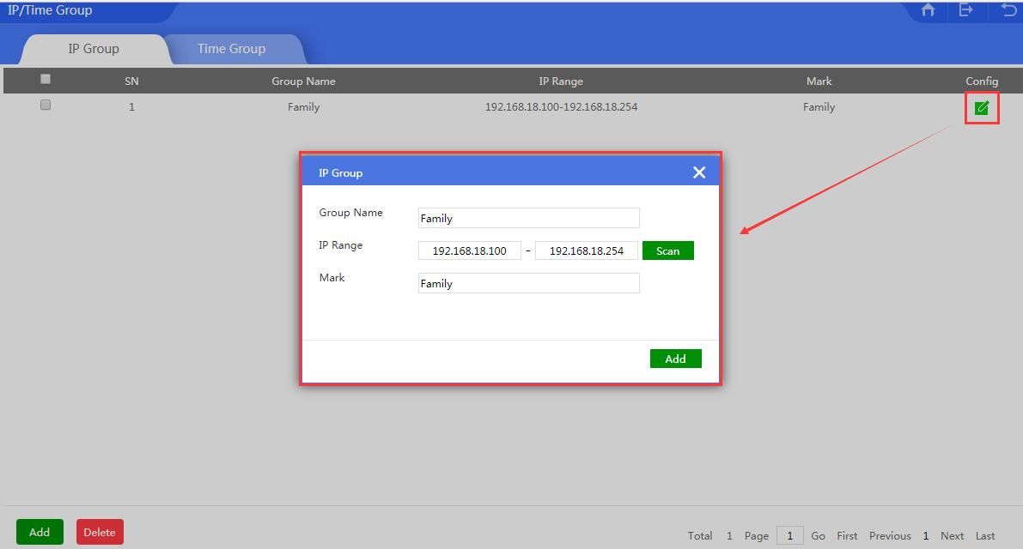

Time Group: The user can add time group based on requirement.
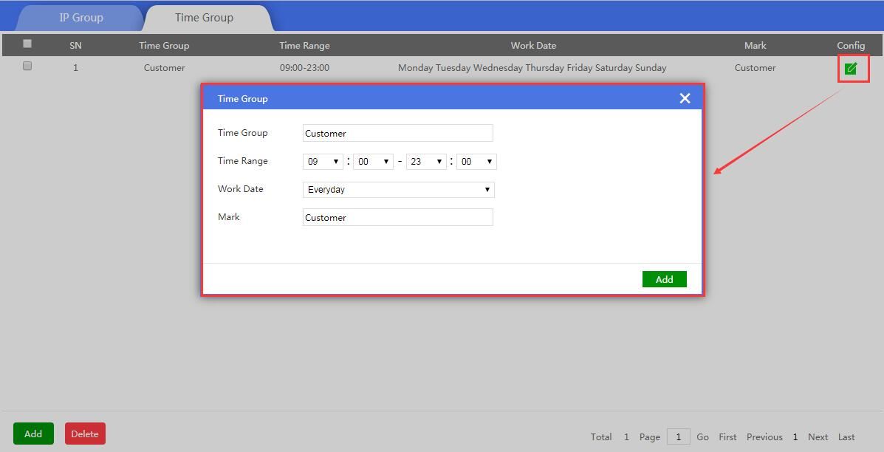

3.8.2.6 Behavior
This feature allows/rejects specific behaviors of end users based on rules.
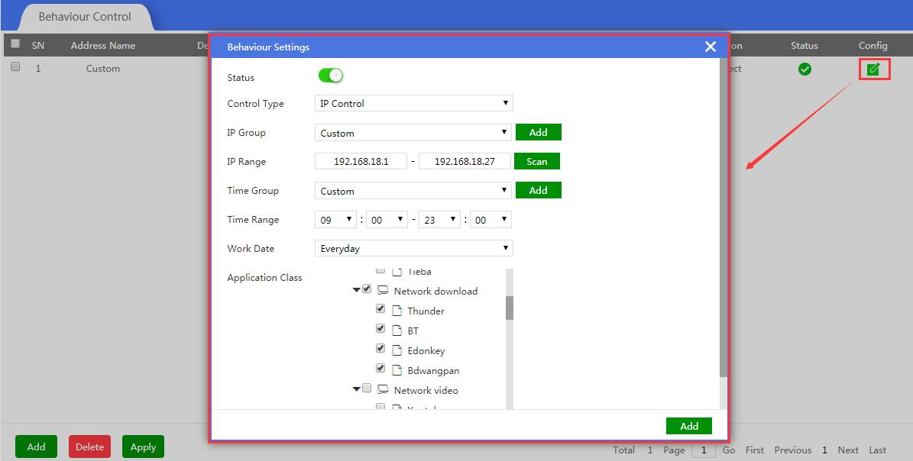

3.8.2.7 Flow Control
Flow Control means Ethernet speed limit, to limit end users Ethernet speed.
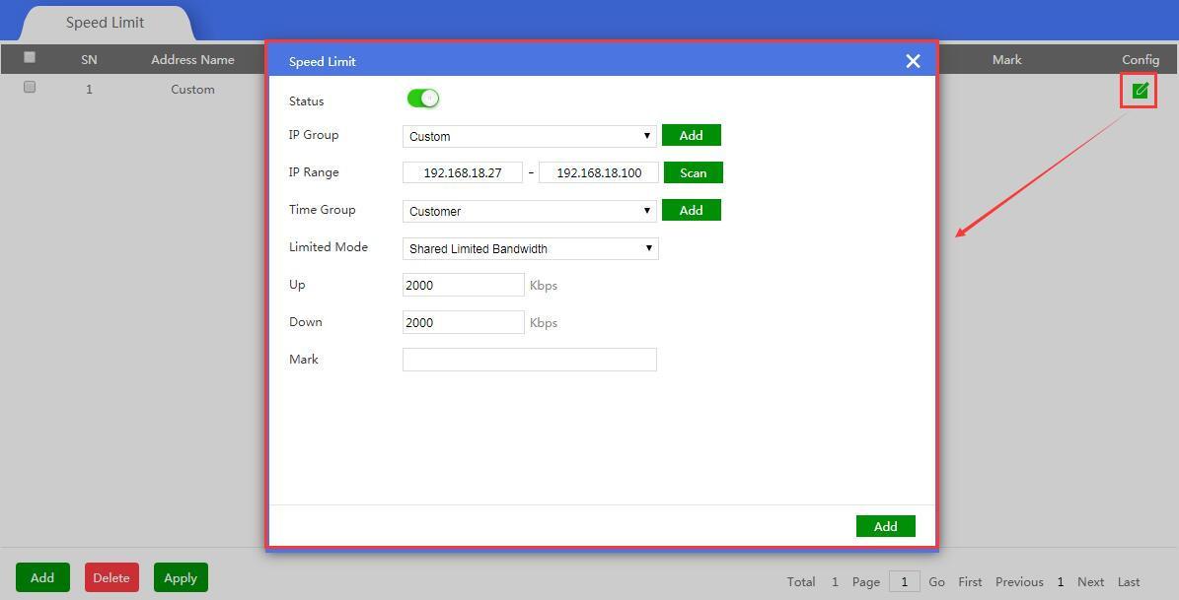

3.8.3 Network
This includes Wi-Fi Settings, LAN Settings, WAN Settings and DDNS Settings.
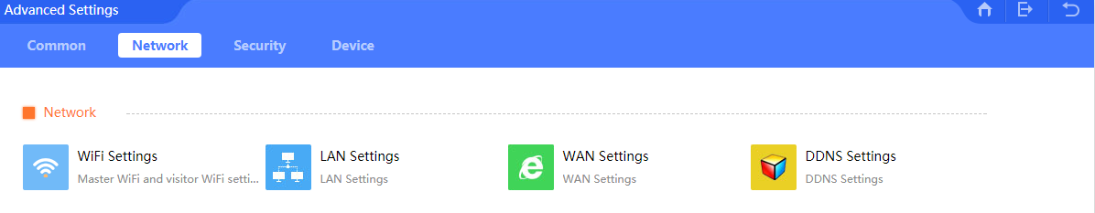

3.8.3.1 Wi-Fi Settings:
Please refer to Chapter 3.3

3.8.3.2 LAN Settings:
Please refer to Chapter 3.4

3.8.3.3 WAN Settings:
Please refer to Chapter 3.5

3.8.3.4 DDNS Settings:
DDNS or Dynamic DNS, is a method of automatically updating a name server in the Domain Name System (DNS), often in real time, with the active DDNS configuration of its configured hostname, address or other information.

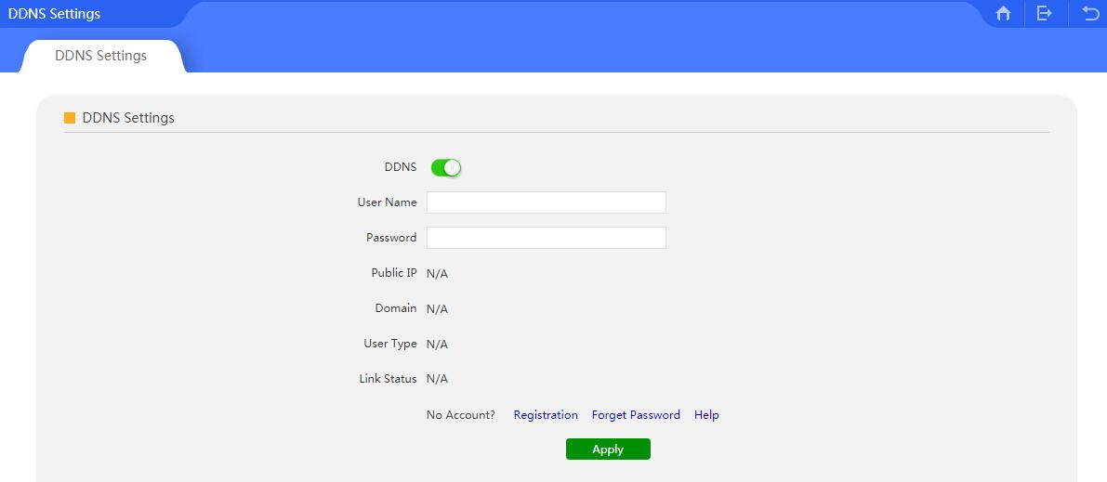

3.8.4 Security
This includes port mapping, IP Filter, URL Filter, MAC Filter, MAC Filter, and DMZ.
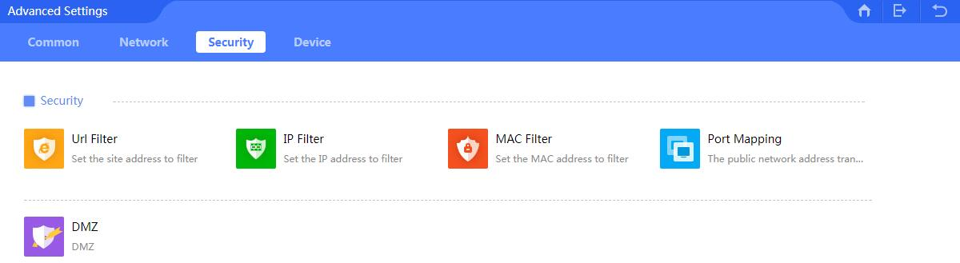

3.8.4.1 URL Filter
Please refer to chapter 3, 3.6 URL Filter part.

3.8.4.2 IP Filter
By enabling this function, the router will either allow or limit the specific IP address to access into the broadband router based on rules.

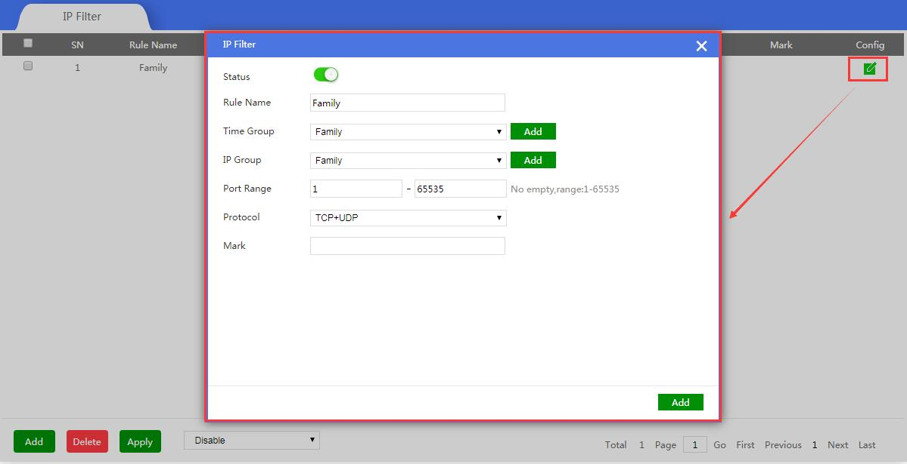

3.8.4.3 MAC Filter
By enabling MAC filter, the router will allow or prohibit the MAC address to access this router based on rules.

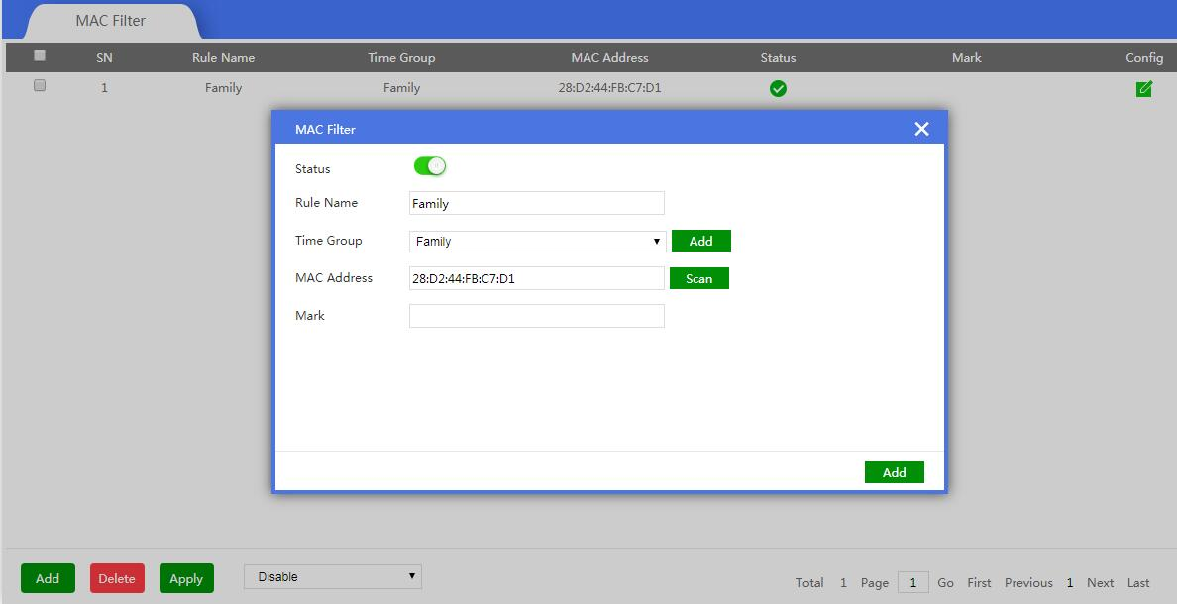

3.8.4.4 Port Mapping
Port Mapping, also called port forwarding , is an application of network address translation(NAT) that redirects a communication request from one address and port number combination to another while the packets are traversing a network gateway, such as a router or firewall.

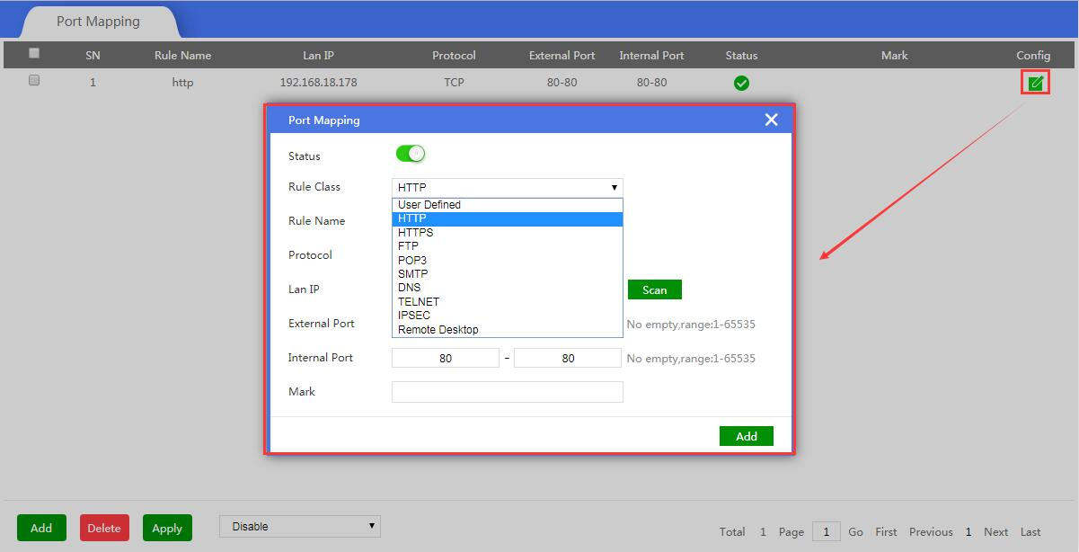

3.8.4.5 DMZ
DMZ or Demilitarized Zone is a physical or logical subnetwork that contains an exposes an organization’s external-facing service to a usually larger and untrusted network, usually the Internet. The purpose of a DMZ is to add an additional layer of security to an organization’s local area network, an external network node can access only what is exposed in the DMZ, while the rest of organization’s network is firewall.

